Zac Crane

14151501

11NOV2015

Research Paper

Chrome Wheel’s is creating a turn based strategy game for the google Chromecast. The Chromecast is a device that allows a user to stream media to a television ("Chromecast - Google."). The device works by connecting to the user’s local Wi-Fi router. Once connected, the user is able to cast content from their device to the television that the Chromecast is connected to. However, media is not the only thing the Chromecast is capable of doing, it also supports various video games, from single player to multiplayer. Right now there are a few problems that the group is looking into, this research paper is going to focus on the networking needs of the Chromecast. Some of the problems with the network that need additional research are the minimum Wi-Fi requirements to maintain quality of experience, the hardware needs of the network, Chromecast, and phones, and what the server requirements are as well.

Taking a deeper look into the server requirements for the Chromecast will be the further investigated first. The way the group understands the Chromecast to server relationship is as follows:

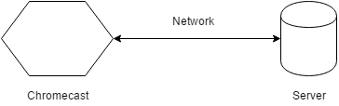

Fig 1:

The Chromecast shown in Figure 1 as a hexagon communicates with a server (shown as a cylinder) over a network connection that allows the two devices to communicate. This shows how the Chromecast receives applications from the google store, not for development.

Upon reading the developer section of the Chromecast webpage, it became apparent that the above Figure was not how Chromecast development works. The developer’s page states that there are two applications that need to be created, a sender and a receiver ("Get Started."). These two applications are modeled in Figure 2 below:

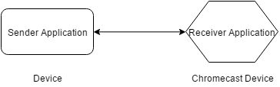Fig 2:

This figure shows how the applications are divided among the Device and the Chromecast. The Device contains the Sender Application and the Chromecast contains the Receiver Application.

The sender application is written for the actual device that will be connected to the Chromecast unit and is written in regards to the devices operating system ("Get Started."). The receiver application is written for the Chromecast device and comes in two varieties, the first being the default, or styled media player receiver, and the second a custom receiver ("Get Started."). The styled media player will not work for the game that Chrome Wheel’s is developing because it is merely a customizable media interface for audio and or video playback ("Receiver Applications."). This means that the group will be developing a custom interface to allow the Chromecast to communicate with the devices that will be used to play the game. The game application will allow up to 4 Devices to play the game over the Chromecast and the network is modeled below in Figure 3:

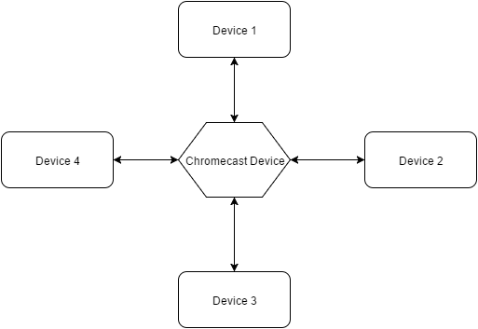Figure 3:

The Chromecast is modeled above with 4 devices communicating with it. This is a network map of the maximum amount of network traffic the game will host. The game will support up to 4 devices.

Now that the server requirements have been clarified and the relevant network structure for the Chromecast have been clarified, the hardware requirements will be discussed in depth.

Chrome Wheel’s is developing a turned based strategy game as previously stated. This will keep the hardware requirements to a minimum. Since each device will take turns communicating with the Chromecast receiver application, the game should suffer minimum quality of experience degradations from poor Wi-Fi components. This is not to say that the Wi-Fi performance will not be an issue, but that the users should not witness any noticeable lag in the gameplay like some real time games experience. The Chromecast’s latest generation supports wireless b/g/n/ac 2.4/5g network ("Set up Chromecast."). In order to make use of the Chromecast, all devices must support the same wireless standards. This means that a device that is only B capable will hinder network performance of the Chromecast to b standards. Since this will be a turn based game, Chrome Wheel’s should be fine with a wireless b connection, but depending on the traffic load this is subject to change. Research on network traffic for a multiplayer Chromecast game that is turn based returned no results. This means that the network requirements will need to be decided once the game is being tested. The Chromecast will need a power supply to operate as outlined in the getting started section of the Chromecast webpage ("Set up Chromecast."). This section also outlines the hardware requirements for the devices as needing wireless b or better and be running iOS, Android or ChromeOS ("Set up Chromecast."). Windows and mac are also supported, but will not be developed by the group ("Set up Chromecast.").

In conclusion, Chrome Wheel’s has a better understanding of how the development process works with the Chromecast. The previous model of requiring a server for development work has been disproven by the documentation for the Chromecast provided by Google. This frees up the internet requirement at all, since the Chromecast will be connected to Wi-Fi in order to establish a connection to the devices. The hardware requirements for the game will need to be established at a later point due to lack of supporting research for turn based strategy games. The group will need to test various network configurations in order to determine what the minimum hardware requirements will be for the game to run with an acceptable quality of experience. Wireless b will be the starting point since this is the minimum network capability of the Chromecast. This means that the hardware requirements will be a wireless capable device running iOS, Android, or ChromeOS. This should help the group from hitting any speedbumps when it comes time to develop the application.

Works cited

1. "Chromecast - Google." Chromecast. Web. 16 Nov. 2015. <https://www.google.com/intl/en_us/chromecast/?utm_source=chromecast.com>.
2. "Get Started." Google Developers. Web. 16 Nov. 2015. <https://developers.google.com/cast/docs/developers>.
3. "Receiver Applications." Google Developers. Web. 16 Nov. 2015. <https://developers.google.com/cast/docs/receiver_apps#styled>.
4. "Set up Chromecast." - Chromecast Help. Web. 16 Nov. 2015. <https://support.google.com/chromecast/answer/2998456?hl=en>.